## CHAPTER 1: INTRODUCTION

## Which of the following descriptions below correspond to a *"nuts-and-bolts"* view of the Internet?

* A "network of networks".
* A collection of hardware and software components executing protocols that define the format and the order of messages exchanged between two or more communicating entities, as well as the actions taken on the transmission and/or receipt of a message or other event.
* A collection of billions of computing devices, and packet switches interconnected by links.

Which of the following descriptions below correspond to a *"services"* view of the Internet?

* A place I go for information, entertainment, and to communicate with people.
* A platform for building network applications.

Which of the following human scenarios involve a protocol (recall: "Protocols define the format, order of messages sent and received among network entities, and actions taken on message transmission, receipt")?

* Two people introducing themselves to each other.
* One person asking, and getting, the time to/from another person.
* A student raising her/his hand to ask a really insightful question, followed by the teaching acknowledging the student, listening carefully to the question, and responding with a clear, insightful answer. And then thanking the student for the question, since teachers *love* to get questions.

## Access network per-subscriber speeds.

* Ethernet: Wired. Up to 100's Gbps per link.
* 802.11 WiFi: Wireless. 10’s to 100’s of Mbps per device.
* Cable access network: Wired. Up to 10’s to 100’s of Mbps downstream per user.
* Digital Subscriber Line: Wired. Up to 10’s of Mbps downstream per user.
* 4G cellular LTE: Wireless. Up to 10’s Mbps per device.

Which of the following physical layer technologies has the highest transmission rate *and* lowest bit error rate in practice? Fiber optic cable

Choose one the following two definitions that makes the correct distinction between routing versus forwarding.

* Forwarding is the local action of moving arriving packets from router’s input link to appropriate router output link, while routing is the global action of determining the source-destination paths taken by packets.

Which of the characteristics below are associated with the technique of *packet switching*?

* Congestion loss and variable end-end delays are possible with this technique.
* This technique is used in the Internet.
* Data may be queued before being transmitted due to other user’s data that’s also queueing for transmission.
* Resources are used on demand, not reserved in advance.

Which of the characteristics below are associated with the technique of *circuit switching*?

* This technique was the basis for the telephone call switching during the 20th century and into the beginning of this current century.
* Reserves resources needed for a call from source to destination.
* Frequency Division Multiplexing (FDM) and Time Division Multiplexing (TDM) are two approaches for implementing this technique

Suppose there are 20 circuits between A and B, 19 circuits between B and C, 15 circuits between C and D, and 16 circuits between D and A. What is the maximum number of connections that can be ongoing in the network at any one time? 70

When we say that the Internet is a “network of networks,” we mean?

* The Internet is made up of access networks at the edge, tier-1 networks at the core, and interconnected regional and content provider networks as well.
* The Internet is made up of a lot of different networks that are interconnected to each other.

Queueing delay: Time spent waiting in packet buffers for link transmission.

Processing delay: Time needed to perform an integrity check, lookup packet information in a local table and move the packet from an input link to an output link in a router

Propagation delay: Time need for bits to physically propagate through the transmission medium from end one of a link to the other

Transmission delay: Time spent transmitting packets bits into the link.

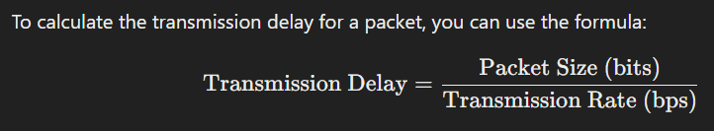

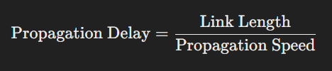

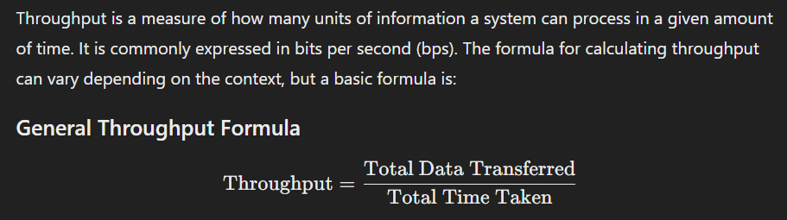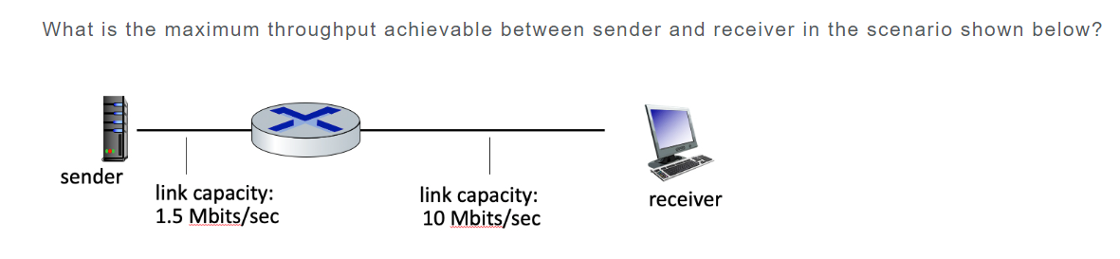

-> 1.5 Mbps

Transport layer: Transfer of data between one process and another process (typically on different hosts).

Physical layer: Transfer of a bit into and out of a transmission media.

Network layer: Delivery of datagrams from a source host to a destination host (typically).

Link layer: Transfer of data between neighboring network devices.

Application Layer: Protocols that are part of a distributed network application.